**‘Create schedule’ -> ‘From’ section -> ‘clock’ icon is clicked -> time selection popup appears -> Time is selected**

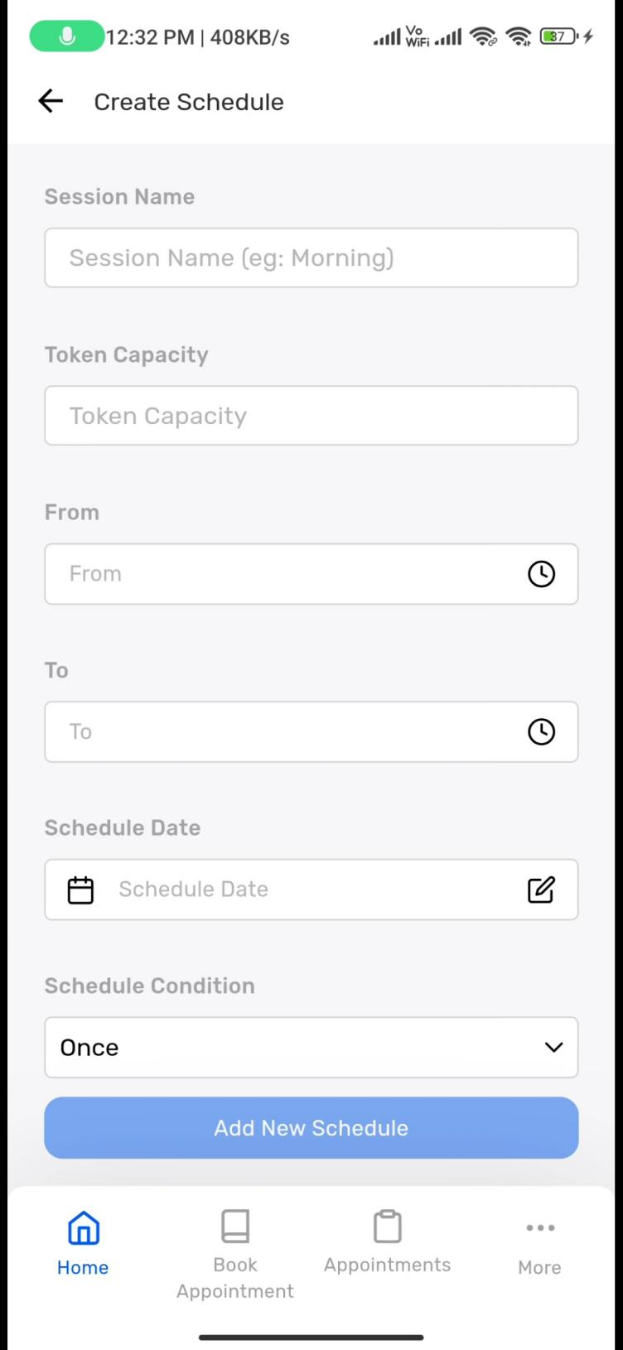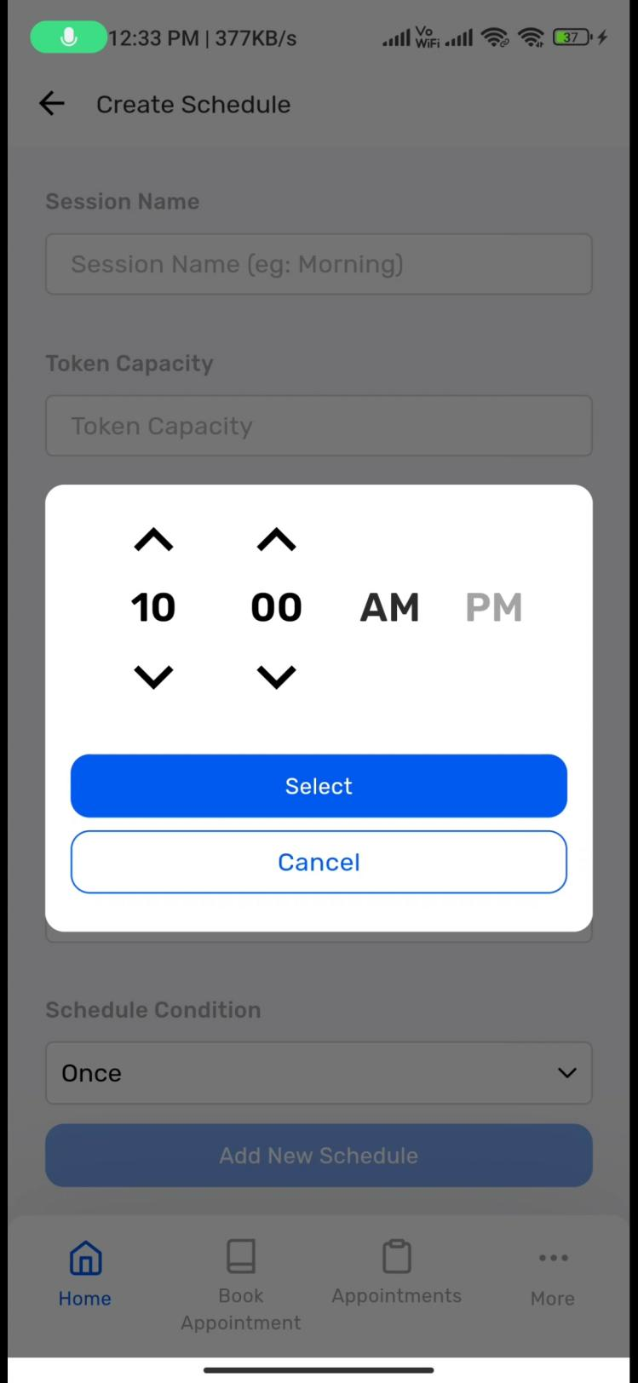

**‘Schedule Date’ section -> ‘date’ icon is clicked -> date window open -> date is selected -> ‘Schedule condition’ dropdown selected --> Dropdown with ‘Once’, ‘Daily’ and ‘Custom’ fields are displayed**

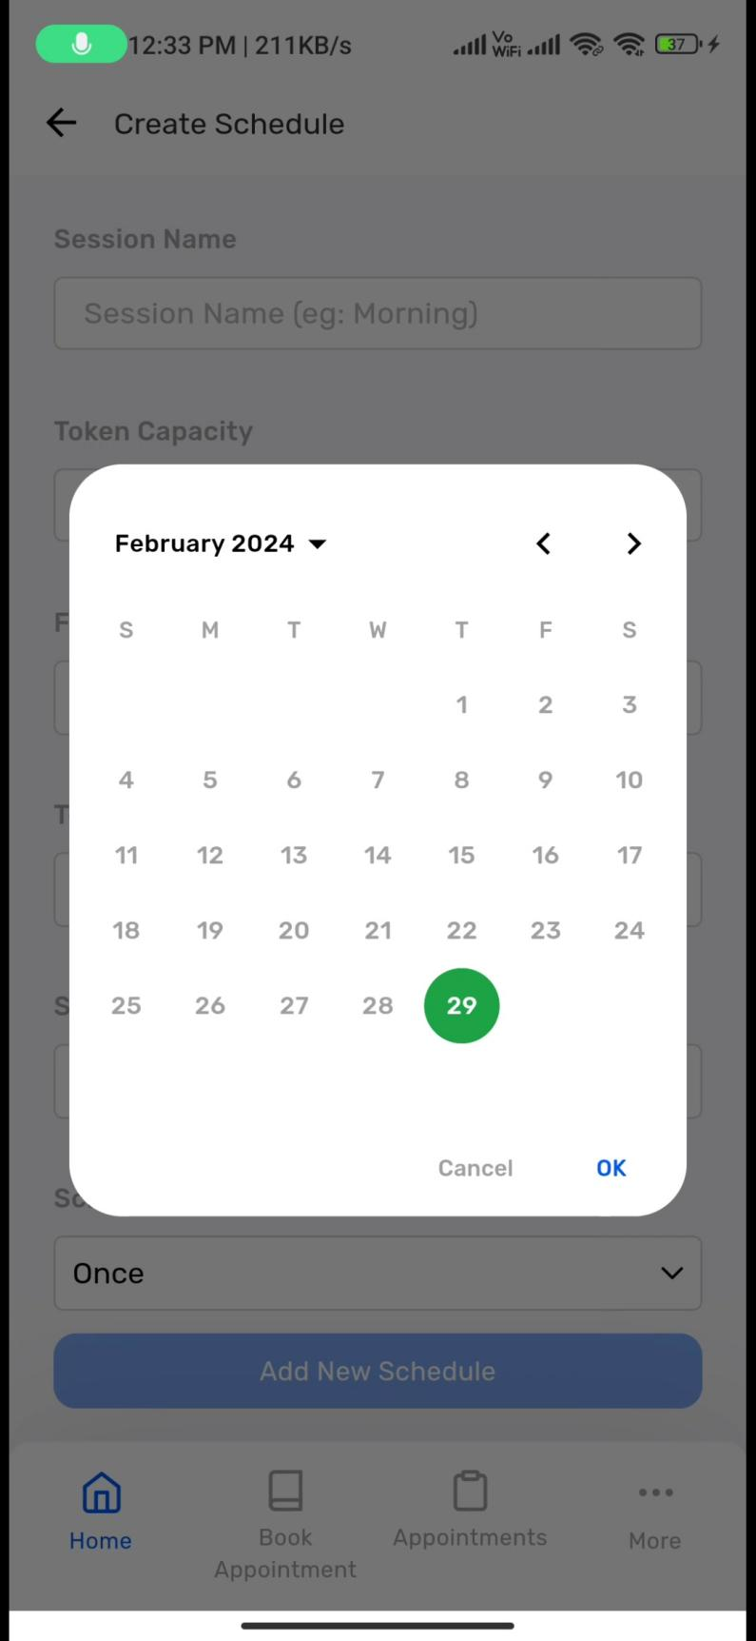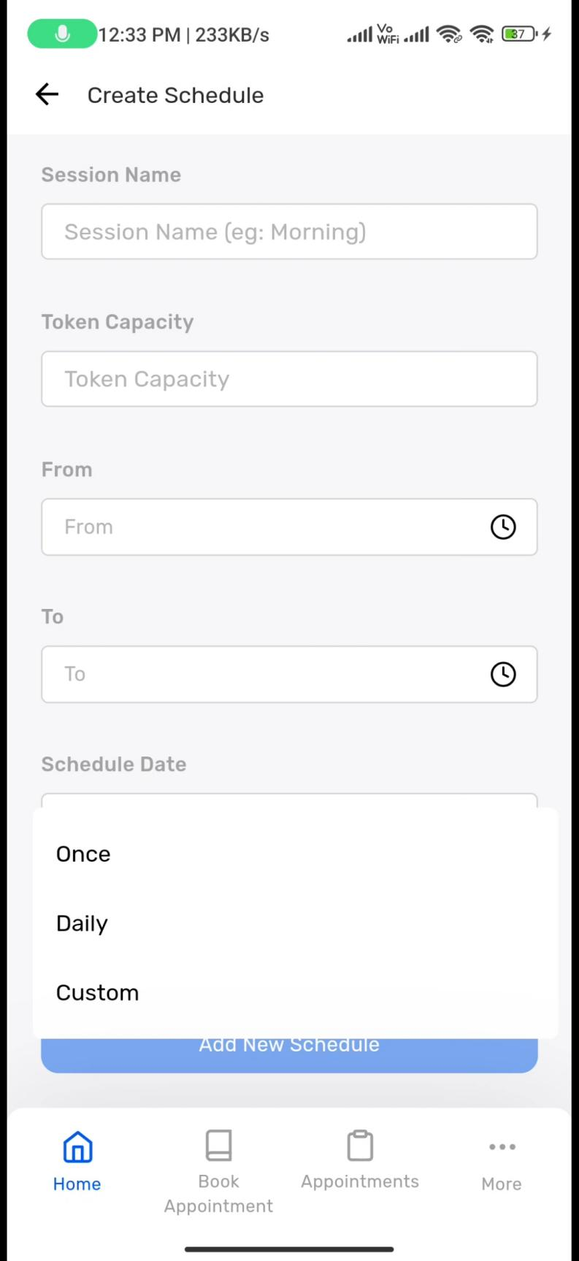

**‘Schedule condition’ section -> dropdown displayed -> ‘Custom’ is selected -> No new details when ‘once’ and ‘daily’ is clicked -> Days changed to weeks**

.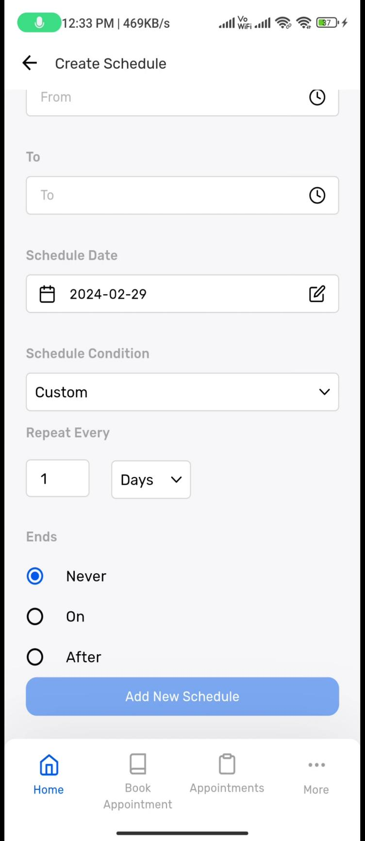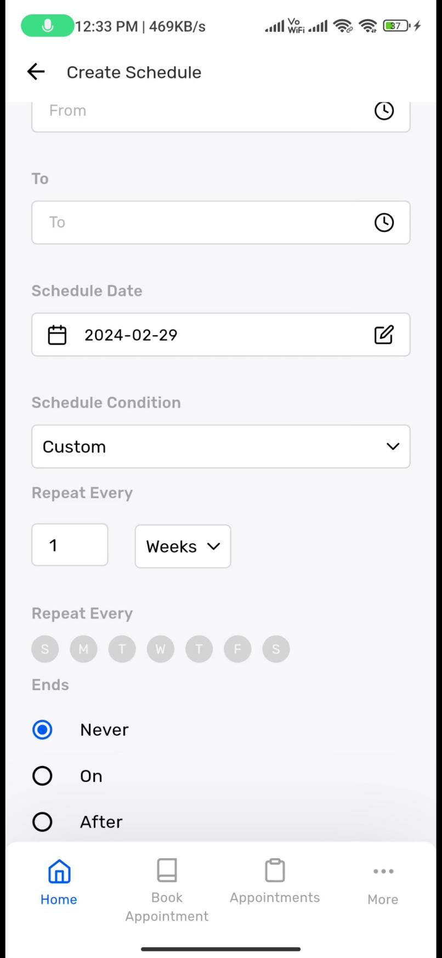

**‘Repeated Every’ section -> ‘Weekdays’ are selected -> ‘Weeks’ changed to ‘Months’ --> Date is entered in second field**

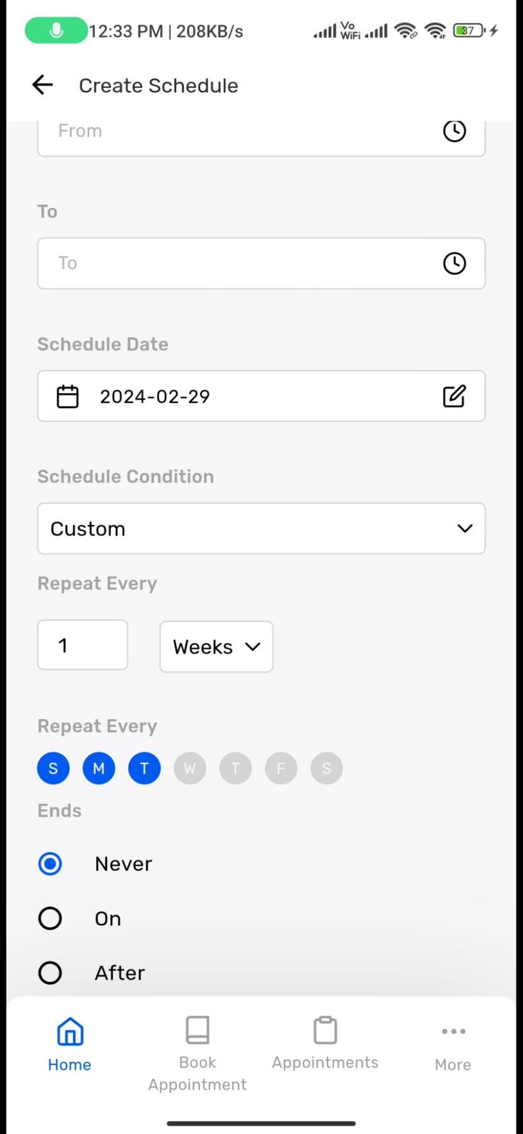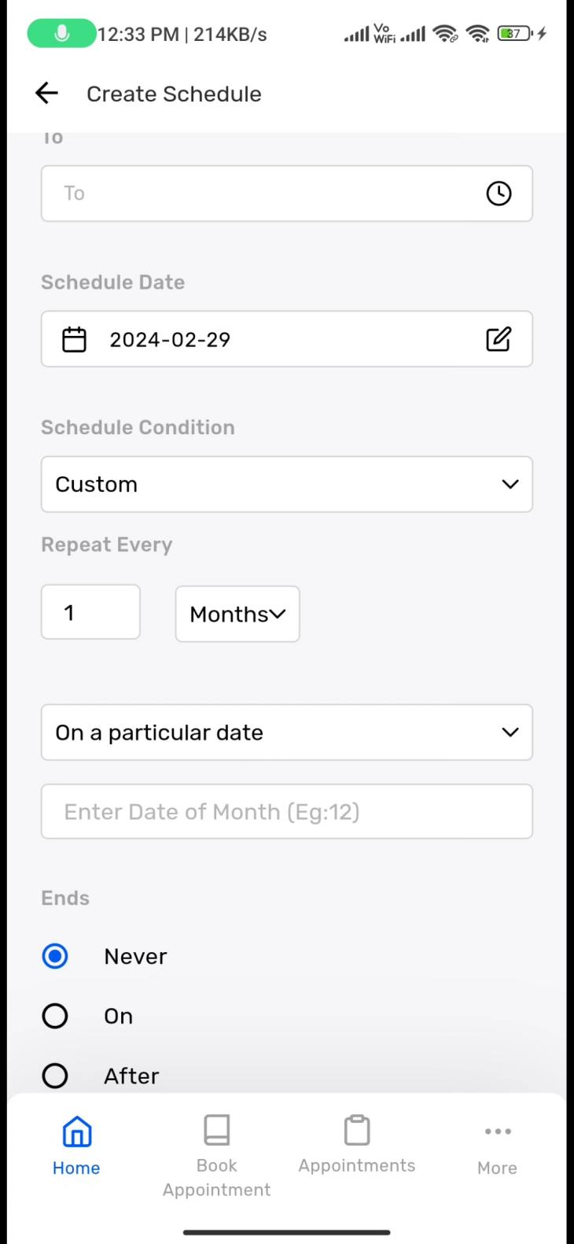

**Dropdown is clicked -> ‘On a particular day and week’ is selected**

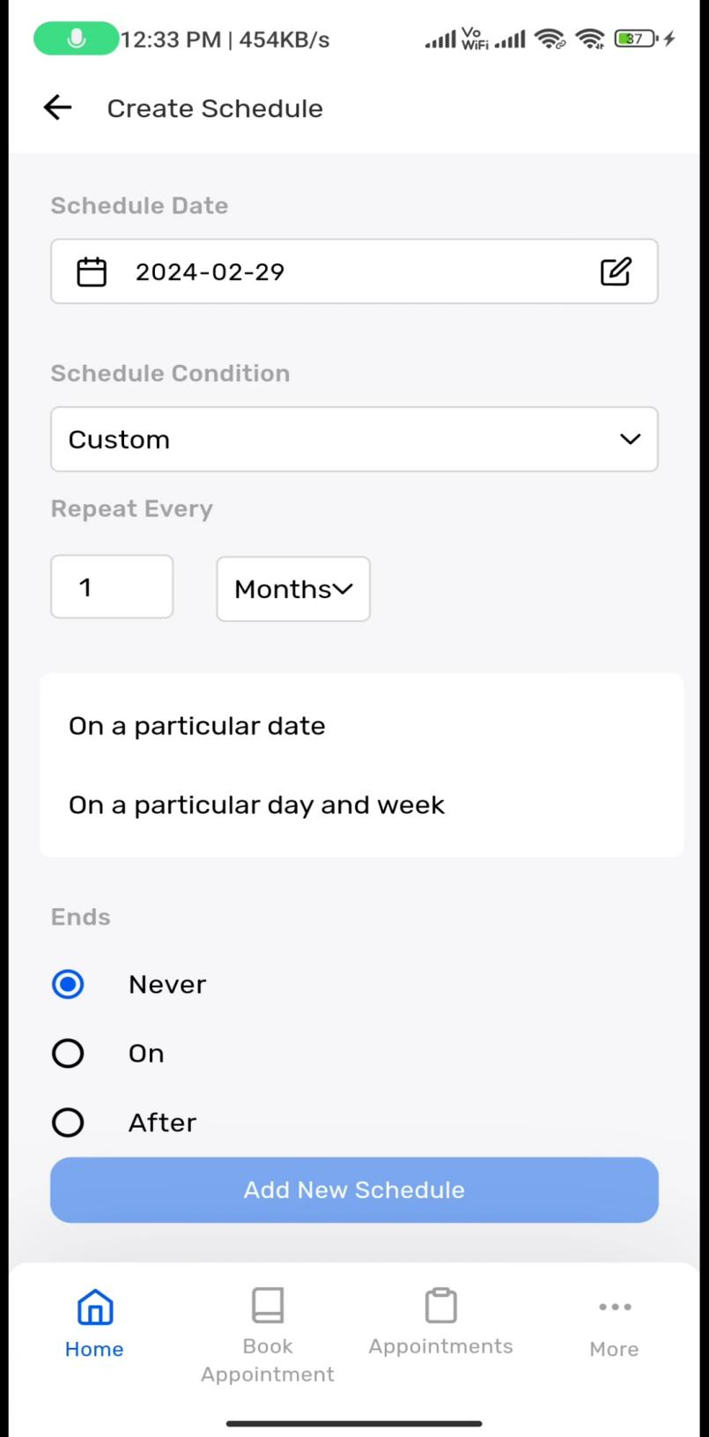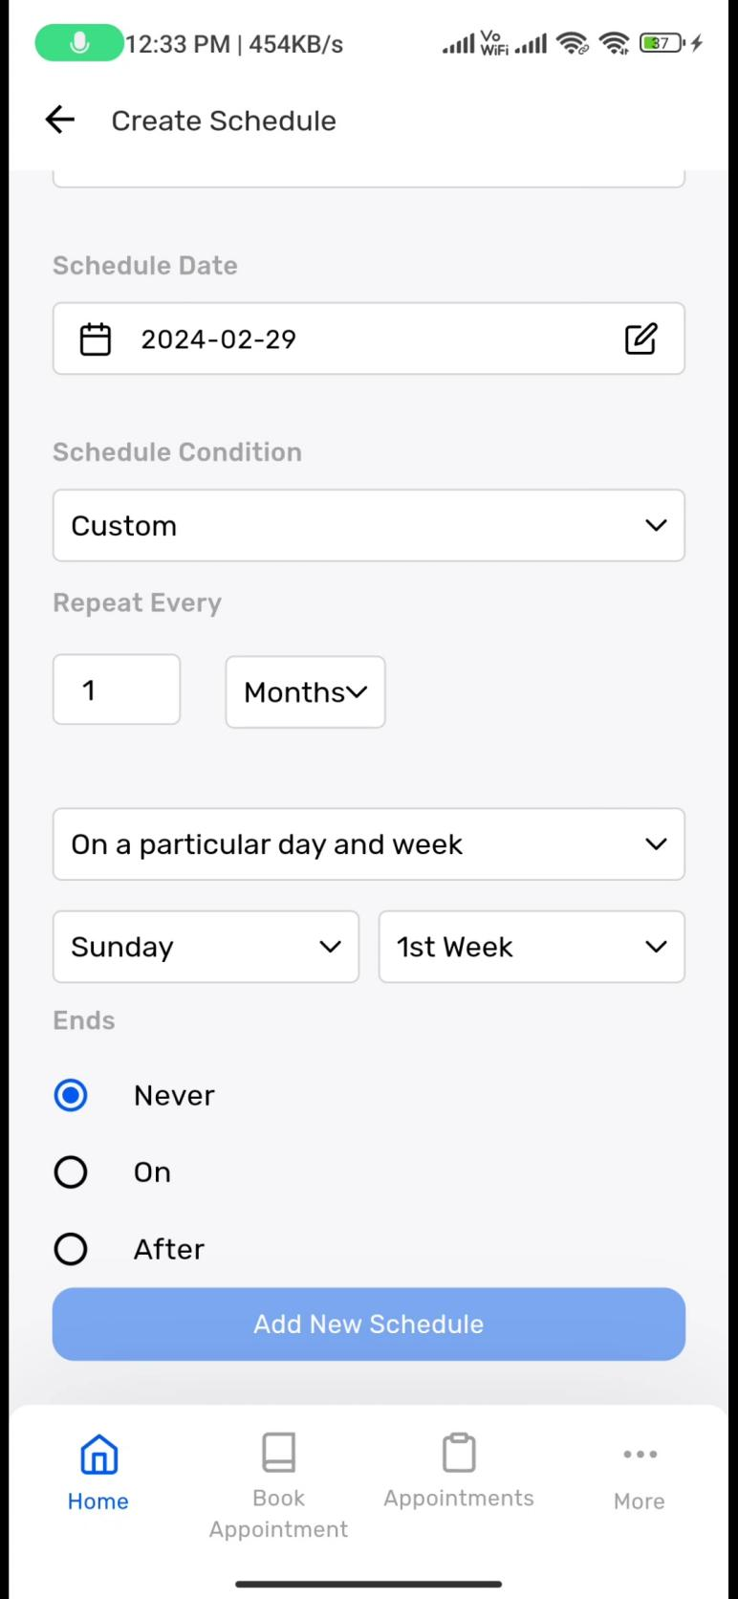

**‘Weekday’ dropdown selected and changed -> ‘first week’ dropdown is selected and changed**

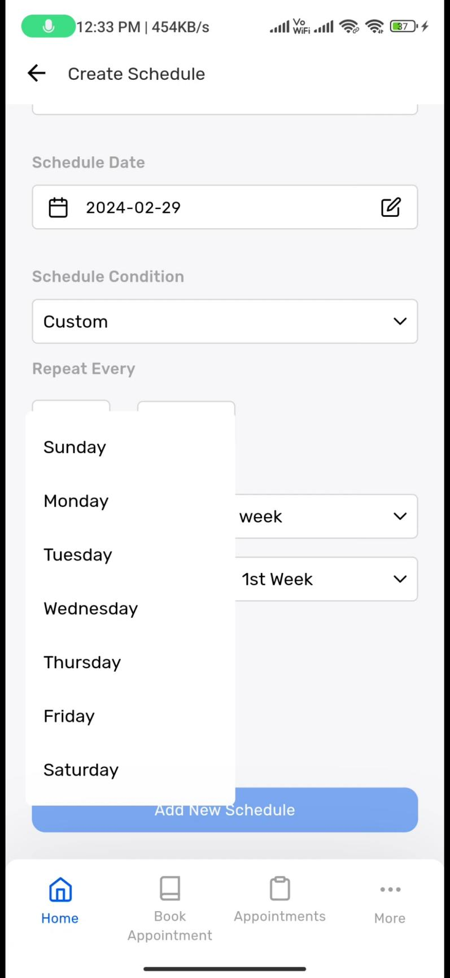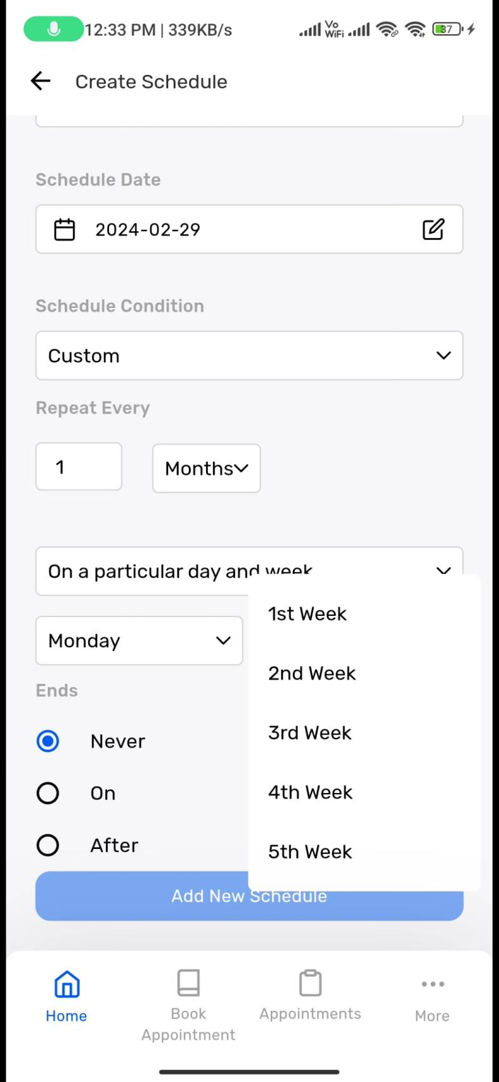

**‘Ends’ section -> ‘on’ radiobutton clicked -> ‘pencil’ icon in select date field Is selected -> ‘Date’ window opens -> Date selected**

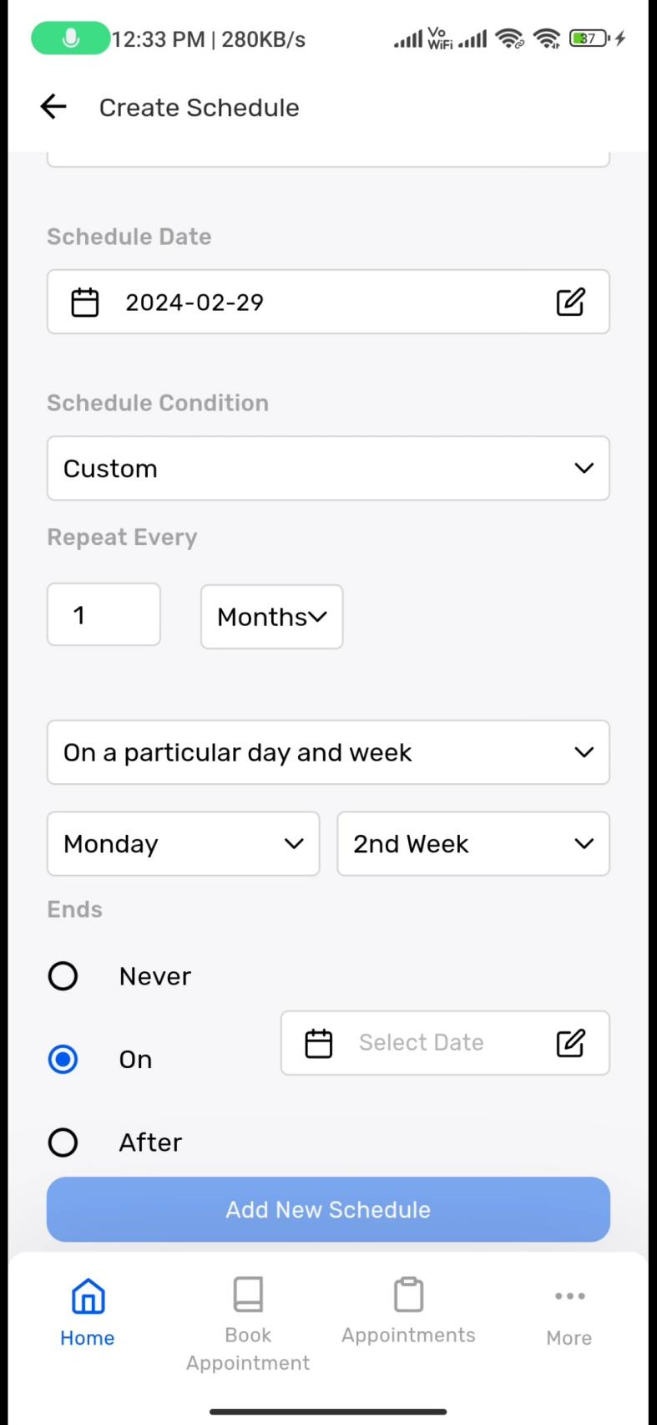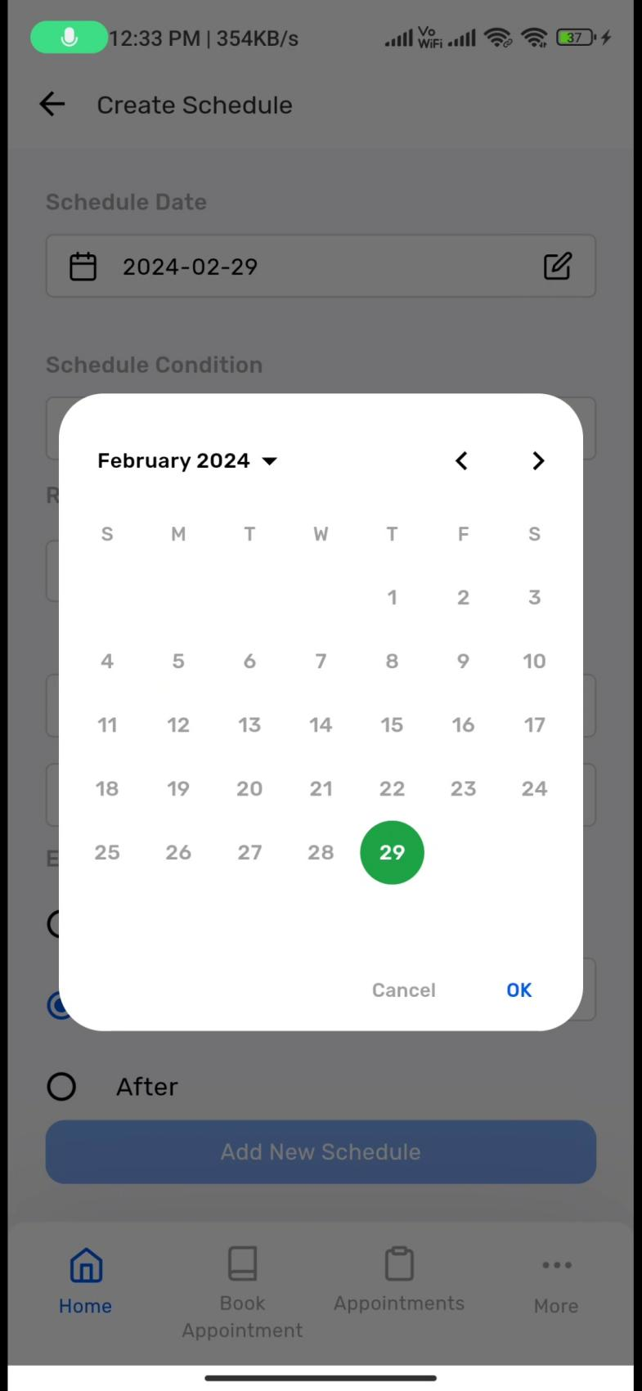

**‘After’ button is clicked -> ‘occurrences’ number entered -> ‘Add new schedule’ button clicked -> schedule created**

